Question:1
Write a C program that takes 5 integers in an array and shifts all elements one position to the right, and moves the last element to the first position.
Example:
Input → 1 2 3 4 5
Output → 5 1 2 3 4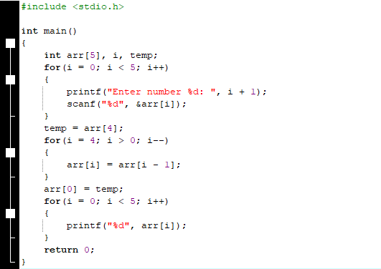
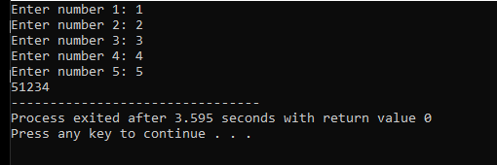

Question:2
Write a program that reads the 10 numbers from user and store these numbers into an array of same size. You program should provide a searching mechanism in such a way that how many times a particular number occurred and then print it on screen. If number is not in array, then program should display a message “number not found”.
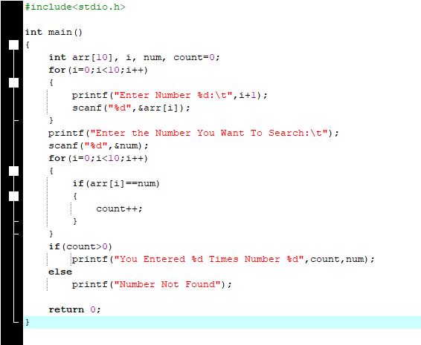
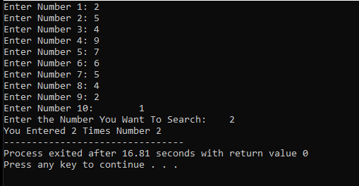

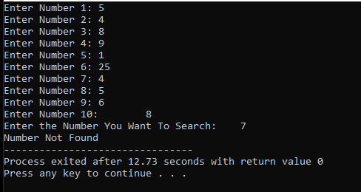
Question:3
Sir Saif ask you to write a program which can help him in storing your quiz marks for pass students within range [5-10] will be stored, consider there are 10 students registered in Section BSE-1B. He wants an array of same size where marks for failed students within range [0-5] are stored. Write a program for the given scenario. You program should exit if user enters -1 and fill display the marks entered along with average of each array.
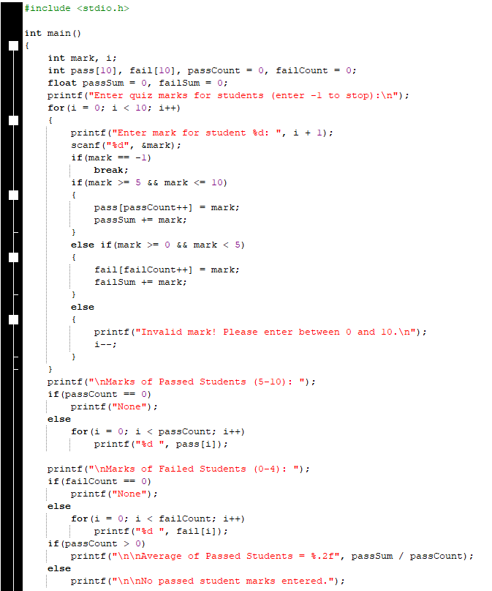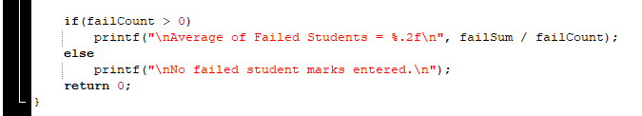
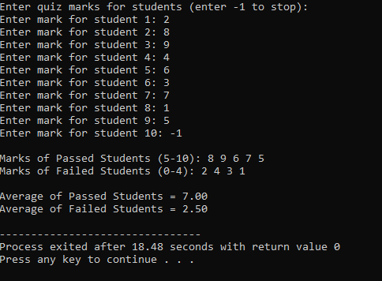
Question:4
Your class teacher asks you to develop a program that can help in converting mixed-case messages entered by users. The program should read a sentence using scanf(”%[^\n]”, str); and then convert all lowercase letters to uppercase and all uppercase letters to lowercase, without using any string library functions. Finally, display the converted message back to the user. Example: Input → HeLLo WoRLd → Output → hEllO wOrlD
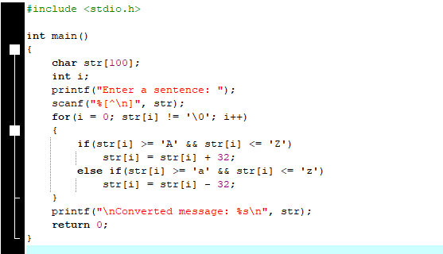
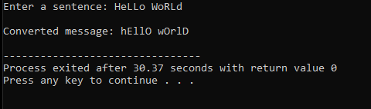
Question:5
Write a program that reads 10 integers into an array. Finds and prints the difference (max - min) between the largest and smallest elements.
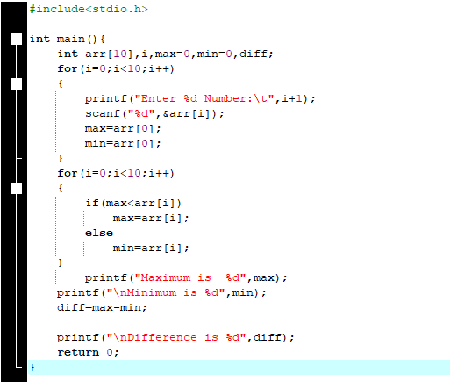
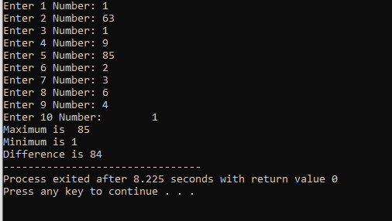
Question: 6
You are assisting your English language teacher who wants to analyze how many vowels and consonants appear in students’ submitted words. Write a program that reads a single word using scanf(“%s”, str); and counts the number of vowels and consonants in it without using any string library functions like strlen(). The program should display both counts on the screen.
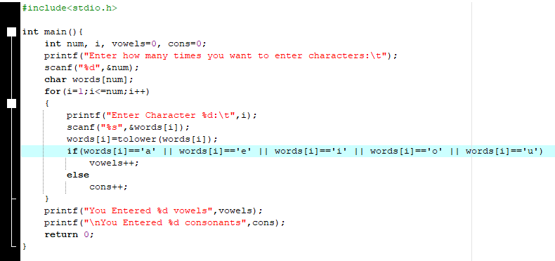
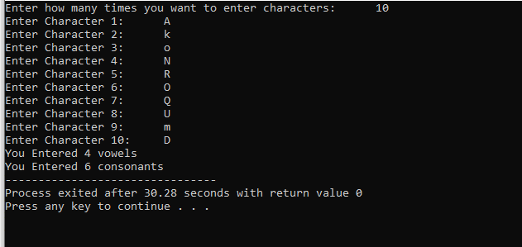
Question:7
You are working in a data management department where you are asked to remove duplicate entries from a list of recorded IDs. Write a program that takes 10 integers from the user and stores them in an array. The program should replace every duplicate element (after its first occurrence) with -1 to mark it as a duplicate and then display the final updated array on the screen.
Example: Input → 2 3 5 3 5 9 1 2 8 1 → Output → 2 3 5 -1 -1 9 1 -1 8 -1
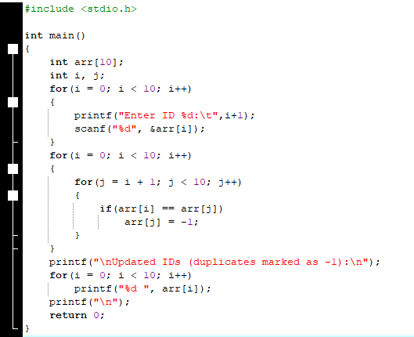
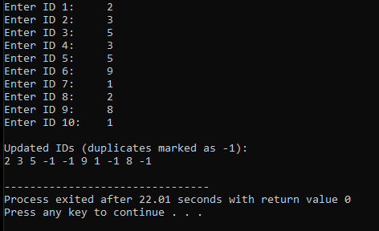
Question:8
Write a program that reads a string using scanf(&quot;%[^A-Za-z]&quot;, str); so that it accepts and stores all characters except alphabets. The program should then display the entered non-alphabetic characters on the screen.
